*Florida International University*

*School of Computing and Information Sciences*

Software Engineering Focus

Feature Document

User Story ID <680 Snack Score>

**Name:Bertha M Perez**

**Frank Hernandez**

**Team Member(s): Bertha M Perez**

**Frank Hernandez**

**Project: Snackability 1.0**

**Product Owner(s)**: Dr. Cristina Palacios

**Mentor(s)**: Dr. Cristina Palacios

**Instructor**: Masoud Sadjadi

**User Story Name:** 680 Snack Score

### Description:

* As a user I would like to get a snack score so that I know how health this snack is as per the USDA guidelines

### Acceptance Criteria:

1. Enter a snack
2. Enter serving size
3. Select if the snack is processed or not

### Note:

As per meeting with the product owner, she have requested to ask the user if the snack is highly processed or not so we can obtain a more accurate score.

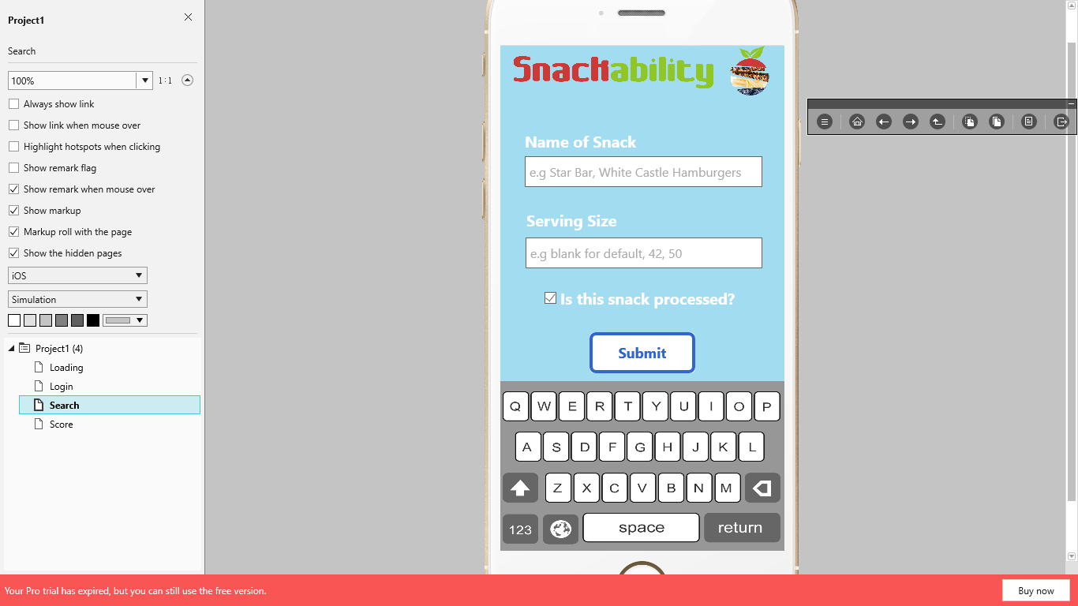

To program score we follow these guidelines:

|  |  |
| --- | --- |
| **Principle** | **Score** |
| **1. Contain ≥50% whole grains by weight; 1st ingredient is a fruit, a vegetable, a dairy product, or a protein food; or combination of fruit and/or vegetable** | 2 |
| **2. Nutrient standard for:** |  |
| **Calories ≤ 200 calories** |  |
| 1.0 – 50.0 Kcal | 2 |
| 50.1 – 100.0 Kcal | 1.5 |
| 100.1 – 150.0 Kcal | 1 |
| 150.1 – 200.0 Kcal | 0.5 |
| > 200.0 Kcal | 0 |
| **Total Fat ≤ 35% of calories** |  |
| 0 – 20.0% | 1 |
| 20.1 – 35.0% | 0.5 |
| >35.0% | 0 |
| **Saturated Fat <10% of calories** |  |
| 0 – 4.9% | 1 |
| 5.0 - 9.9% | 0.5 |
| ³ 10% | 0 |
| **Trans Fat 0 g** |  |
| Trans Fat 0 g | 1 |
| Trans Fat > 0 g | 0 |
| **Sodium ≤ 200 mg** |  |
| 0 – 140.0 mg | 1 |
| 140.1 – 170.0 mg | 0.5 |
| 170.1 – 200.0 mg | 0.25 |
| > 200 mg | 0 |
| **Sugar ≤35% by weight** |  |
| 0 – 14.9% | 2 |
| 15.0 – 19.9% | 1.5 |
| 20.0 – 24.9% | 1 |
| 25.0 – 35.0% | 0.5 |
| > 35% | 0 |
| **TOTAL** | **10** |
| **Super score** |  |
| Processed | - 1 |
| Unprocessed | + 1 |

|  |  |  |  |  |
| --- | --- | --- | --- | --- |
| Fruit | Vegetable | Dairy | Whole grain | Protein |
| Apples, Apricots Bananas,CherriesCoconut, Grapes  Coconut Flakes Dates, Grapefruit Figs, Lemons  Fruit cocktail Guava,Kiwi Limes, Mangoes Mandarin, Olives, Oranges Nectarines, Pears Papaya, Peaches Persimmons Pineapple, Plums Pomegranate Prunes, Raisins Passion fruit Star fruit Tangerines Tamarind Acai berries Blackberries Blueberries Cranberries Currants Goji berries Huckleberries Lingonberries (cowberries) Mulberries Raspberries Strawberries Cantaloupe Honeydew Horned melon (kiwano) Watermelon | Artichokes, Arugula Asparagus, Acorn squash Alfalfa sprouts, Avocado Bell peppers, Bok Choy Beets, Butternut squash Broccoli, Bamboo shoots Broccoli rabe, Broccolini  Brussels sprouts, Carrots Bean sprouts, Cabbage Cauliflower, Cassava Chard, Collard greens Celery, Cucumbers Coriander, Green bananas Dark green-leafy Lettuce  Eggplant, Endive, Garlic Escarole, Green peas Green lima beans, Okra Green peppers, Kale Hubbard squash, Leeks Jicama, Romaine Lettuce  Lettuce, Iceberg lettuce Mushrooms, Mesclun Mung bean sprouts Mustard greens, Onions Mixed green, Potatoes Pumpkin, Red peppers Parsley, Pattypan squash Parsnips, Sweet potatoes Plantains, Radishes Radicchio, Red cabbage Radishes, Snap beans Green beans, Spinach Squash, Swiss chard Sweet corn, Scallions Snow peas, Tomatillos Turnips, Turnip greens Tomatoes, Watercress Taro, Water chestnuts Wax beans, Zucchini Yams, Yellow squash Bean burger, Black beans Black-eyed peas, Falafel Chickpeas, Edamame Fava beans, Hummus  Kidney beans, Lentils Lima beans, Navy beans Pinto beans, soy beans Split peas, white beans | light milk regular milk fat-free (skim) milk flavored milks lactose-free milks 1% low fat milk 2% reduced fat milk low fat milk reduced fat milk whole milk cheddar cheese Gouda cheese mozzarella cheese low-fat or 2% mozzarella cheese muenster cheese parmesan cheese provolone cheese Romano cheese Swiss cheese brie cheese camembert cheese cottage cheese feta cheese ricotta Low fat and part- skim Ricotta Edam cheese Goat cheese String Cheese  Holand cheese cheese Light cream cheese Fat Free Cream Cheese low-fat cream cheese low-fat or 2% American cheese  almond milk coconut milk rice milk soy milk cultured low fat milk | amaranth brown rice buckwheat bulgur (cracked wheat) kamut millet muesli oatmeal popcorn quinoa rolled oats sorghum spelt teff whole grain barley whole grain cornmeal whole grain sorghum whole rye wild rice whole grains whole oat flour whole wheat Whole wheat flour Whole-Wheat Couscous Whole grain oats brown rice flour | Beef, Ham Lamb, Duck Chicken, Pork, Turkey, Goose Chicken eggs Duck eggs Sausage, cod Bison, Rabbit Venison, Crab Catfish, Tofu  Flounder Haddock Halibut Herring Mackerel Pollock, Porgy Salmon, sushi Sea bass, Trout Snapper, Tuna Swordfish Tilapia, Clams Crayfish, Lobster Mussels Octopus Oysters Scallops, Shrimp Squid (calamari) Anchovy Sardines Tempeh Texturized vegetable protein (TVP) Veggie burgers Almonds Almond butter Cashews Chia seeds Hazelnuts Mixed nuts Peanuts Peanut butter Pecans Pistachios Pumpkin seeds Sesame seeds Sunflower seeds Walnuts  Giblets, Liver Whey protein Chicken breast Chicken thigh Beef patty |

**Unit Test**

* Test case ID: snack_score_local_ID
* Description/Summary of Test: Given a snack and portion size when the user press search then the app should connect the local database to obtain the snack information to calculate the score and show the Snack Detail page with the score
* Pre-condition: N/A
* Expected Results: System should show the Snack Detail
* Actual Result: System should show the Snack Detail
* Status (Fail/Pass): Pass
* Test case ID: snack_score_usda_ID
* Description/Summary of Test: Given a snack and portion size when the user press search then the app should connect with USDA database to obtain the snack information to calculate the score and show the Snack Detail page with the score
* Pre-condition: N/A
* Expected Results: System should show the Snack Detail
* Actual Result: System should show the Snack Detail
* Status (Fail/Pass): Pass

**Integration Test**

**Visual User Guide** <like one or two screenshots of the feature. For the hardware project, a photo of device is required>